|  |
| --- |
|  |
| **《epay》** **Requirements Analysis**  **V1.0** |

**版 本 历 史**

|  |  |  |  |  |
| --- | --- | --- | --- | --- |
| **版本/状态** | **作者** | **参与者** | **日期** | **备注** |
| 1.0.0 | 黄凯 |  | 8.21 | 创建 |
| 1.0.1 | 黄凯 |  | 8.22 | 完成 |
| 1.1.0 | Chen Xingyu |  | 9.14 | Examined |

Category

1. System Business Usecase Diagram 5

2. Requirements Analysis of Login Business 6

2.1. Login Use Case Diagram 6

2.2. Login Use case description 6

2.2.1. Customer Login Use case description 6

2.2.2. Individual store cashier Login Use case description 6

3. Registration Business Requirements Analysis 7

3.1. Registration Use Case Diagram 7

3.2. Registration use case description 7

3.2.1. Customer Registration use case description 7

3.2.2. Individual shop registeration use case description 8

4. Business of Loss Report Demand Analysis 9

4.1. Business of Loss Report Use Case Diagram 9

4.2. Business of Loss Report use case description 9

4.2.1. Business of Loss Report use case description 9

5. Business of User’s Information Modification Requirement Analysis 10

5.1. Business of user’s information modification use case diagrams 10

5.2. Business of user’s information modification use case description 10

6. Payment services Requirements Analysis 11

6.1. Payment services use case diagrams 11

6.2. Payment services use case description 11

6.2.1. Supermarket Payment use case description 11

6.2.2. Individual store Payment use case description 12

6.2.3. Collection (Personal Edition) use case description 12

6.2.4. Transfer use case description 13

6.2.5. Cash use case description 13

7. Finances management business requirements description 14

7.1. Finances management user case analysis 14

7.2. Finances management use case description 14

7.2.1. Deposit Money Use case description 14

7.2.2. Interest Management use case description 14

8. Collection business requirements description 15

8.1. Collection user case analysis 15

8.2. Collection use case description 15

8.2.1. Individual storeCollection use case description 15

8.2.2. Shop Collection use case description 16

9. Data Reports 17

9.1. Data Reportsuser case analysis 17

9.2. Data Reports use case description 17

10. Server business requirements description 18

10.1. Server user case analysis 18

10.2. Server use case description 18

10.2.1. Request reception use case description 18

10.2.2. Data process use case description 18

10.2.3. Request Response use case description 20

# System Business Usecase Diagram

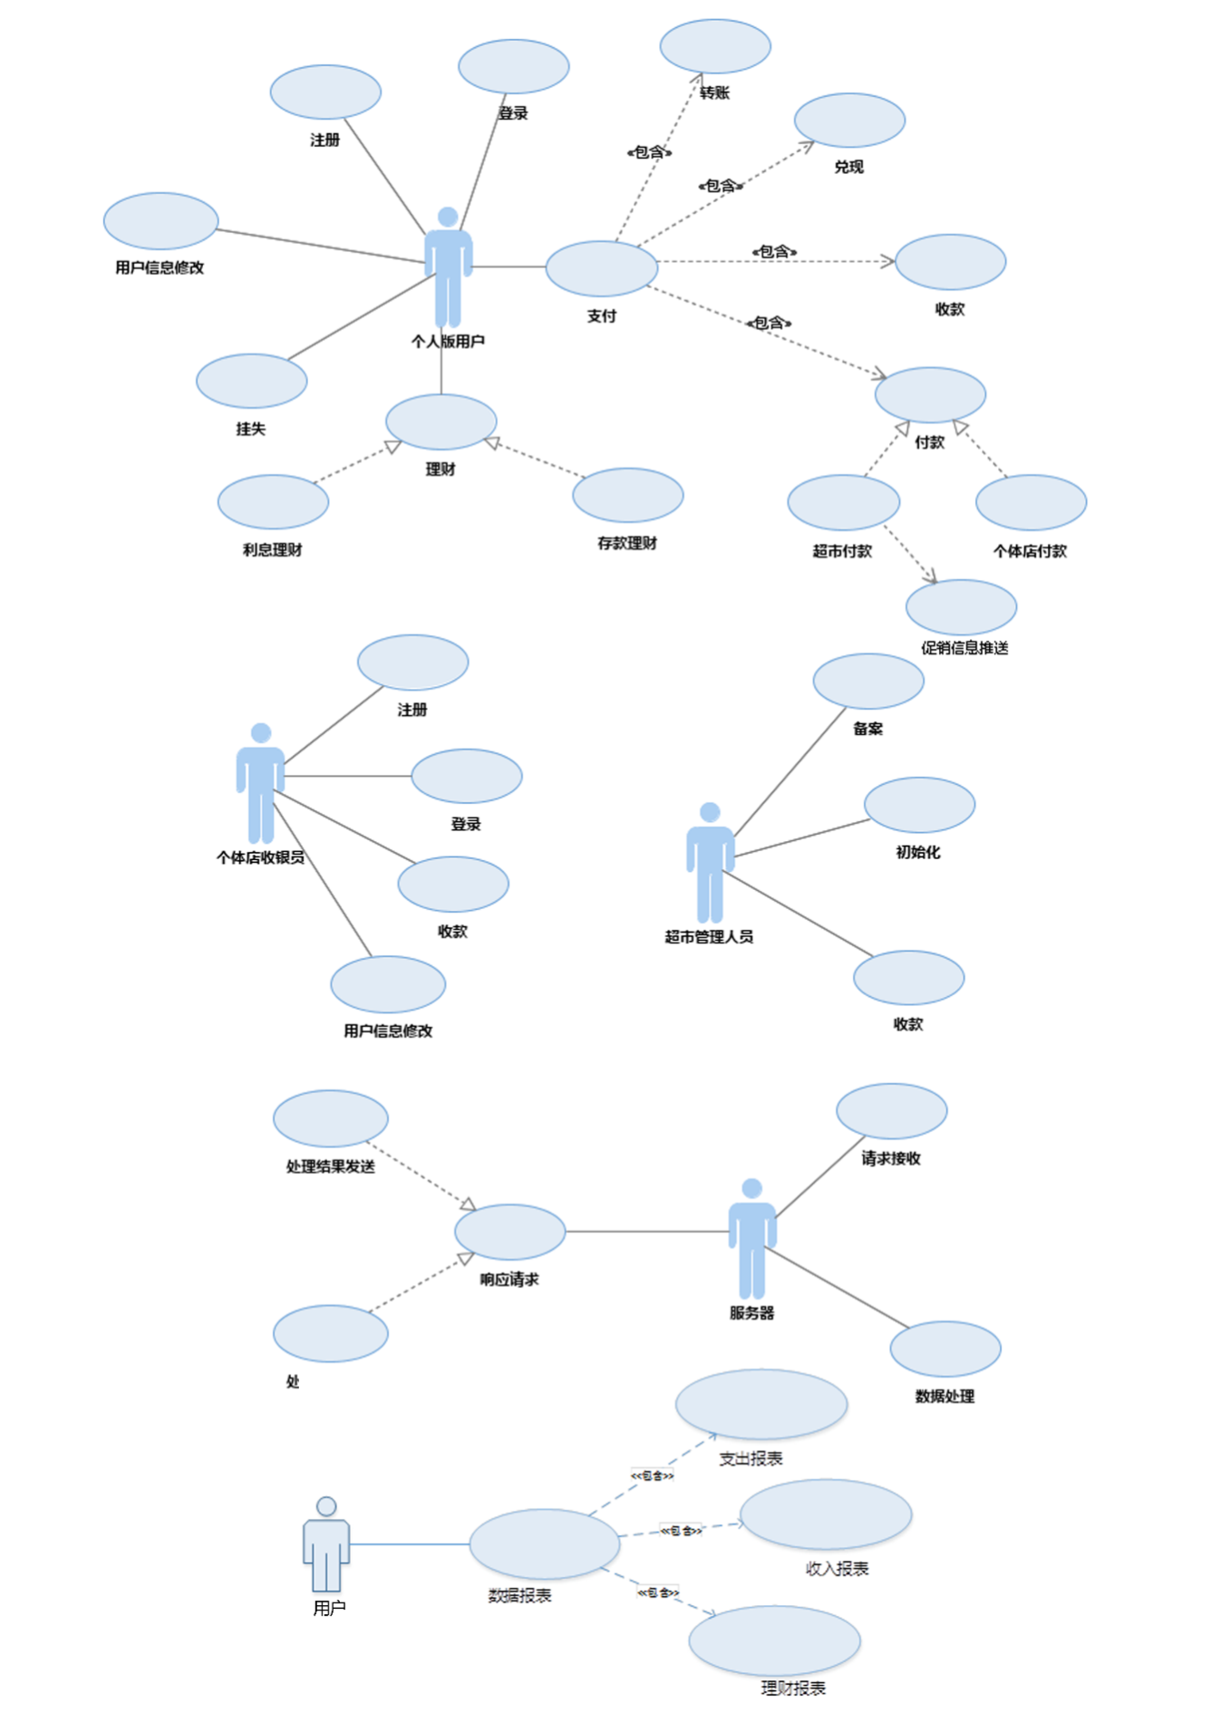

# Requirements Analysis of Login Business

## Login Use Case Diagram



## Login use case description

### Customer login use case description

|  |  |
| --- | --- |
| **ID** | **epay-** Log in **-001** |
| Use Case Name | Log in |
| Participants | Users of Personal Edition |
| Preconditions | User has been registered, and account files exist |
| Event Flow | 1. Enter the username and password  2. Click login  3. check username and password according to the local file  4. Return login results |
| Optionalevents flow | None |
| Abnormal vents flow 1 | Local file does not exist, user needs to send the server bank card number and ID number for verification. If validation is successful, the password file can be downloaded from the server |
| Abnormal vents flow 2 | If username or password is blank or does not meet specifications, it prompts the user to enter the correct username and password |
| Postcondition | A failed login returns reasons for the failure, a successful login leads into the main interface |

### Individual store cashier login use case description

|  |  |
| --- | --- |
| **ID** | **epay-** Log in **-002** |
| Use Case Name | Log in |
| Participants | Individual store cashier Login |
| Preconditions | User has been registered, and account files exist |
| Event Flow | 1. Enter the username and password  2. Click Login  3. check username and password according to the local file  4. Return to login Results |
| Optionalevents flow | None. |
| Abnormal vents flow 1 | Local file does not exist, user needs to send the server bank card number and ID number for verification. If validation is successful, the password file can be downloaded from the server |
| Abnormal vents flow 2 | If username or password is blank or does not meet specifications, prompts the user to enter the correct username and password |
| Postcondition | A failed login returns reasons for the failure, a successful login leads into the main interface |

# Registration Business Requirements Analysis

## Registration Use Case Diagram



## Registration use case description

### Customer registration use case description

|  |  |
| --- | --- |
| ID | epay- Registration -003 |
| Use Case Name | Registration |
| Participants | users of Personal Edition |
| Preconditions | None |
| Event Flow | 1. Click registration  2. Enter the username, password, and real name information,which will be sent to the server  3 After verified, data will be written into the database, and will begin gesture password settings  4. If two gestures password is consistent, set will be successful and begin bank card will binding  5. Enter the bank card number, bank card password, ID number, phone number, sent to the server  6. After confirmation, the data is written into the database, registration is complete |
| Optionalevents flow | None |
| Abnormal vents flow | If username already exists or does not meet specifications, prompts the user to re-enter your username |
| Postcondition | Registration is successful, enter the main interface |

### Individual shop registeration use case description

|  |  |
| --- | --- |
| **ID** | **epay-** registeration **-004** |
| Use Case Name | registeration |
| Participants | Individual store cashier |
| Preconditions | None |
| Event Flow | 1.Click registration  2. Enter the username, password, and real name information,which will be sent to the server  3. Verify that the data will be written to the database through for gesture password settings  4. If two gestures password is consistent, set will be successful and a bank card will be binded  5. Enter the bank card number, bank card password, ID number, phone number, sent to the server  6. After confirmation, the data is written to the database, registration is complete |
| Optionalevents flow | None |
| Abnormal vents flow | If username already exists or does not meet specifications, prompts the user to re-enter your username |
| Postcondition | Registration is successful, enter the main interface |

# Business of Loss Report Demand Analysis

## Business of Loss Report Use Case Diagram



## Business of Loss Report use case description

### Business of loss report use case description

|  |  |
| --- | --- |
| **ID** | **epay-** Business of Loss Report **-005** |
| Use Case Name | Business of Loss Report |
| Participants | users of Personal Edition |
| Preconditions | Phone binded is lost |
| Event Flow | 1. Enter the official site and click to report the loss  2. Enter your username, password, ID number, phone number, and real name  3. Send report the loss of a request for authentication  4. Receive report of loss results |
| Optionalevents flow | None |
| Abnormal vents flow | The information entered is wrong  Data transmission fails, retry |
| Postcondition | After verification, if all information is correct, the account will be frozen so that the account services are not available for all transactions |

# Business of User’s Information Modification Requirement Analysis

## Business of user’s information modification use case diagrams



## Business of user’s information modification use case description

|  |  |
| --- | --- |
| **ID** | **epay-** Business of user’s information modification **-006** |
| Use Case Name | Business of user information modification |
| Participants | Personal Edition users |
| Preconditions | Click the Change Password button or gesture password |
| Event Flow | 1. Enter the old password  2. Enter the new password twice.  3. Modified successfully |
| Optionalevents flow | None |
| Abnormal vents flow | Try to modify the password when the network is not connected. It will tip network conneting request and modify the password with network |
| Postcondition | If the authentication information is correct, then change the password successfully |

# Payment services Requirements Analysis

## Payment services use case diagrams



## Payment services use case description

### Supermarket Payment use case description

|  |  |
| --- | --- |
| **ID** | **epay-** Payment **-007** |
| Use Case Name | Supermarket promotional information push |
| Participants | users of Personal Edition |
| Preconditions | Customer brush dimensional code, two-dimensional code information is displayed as supermarkets, the user clicks on the button to receive promotional information |
| Event Flow | 1. Receive promotional information Picture  2. View Promotions |
| Optionalevents flow | None |
| Abnormal vents flow 1 | Cashier failed to connect, reconnect |
| Abnormal vents flow 2 | Promotional information transmission fails, re-click Send |
| Postcondition | Start shopping |

|  |  |
| --- | --- |
| **ID** | **epay-** Payment **-008** |
| Use Case Name | Supermarket Payment |
| Participants | users of Personal Edition |
| Preconditions | Customer scan two-dimension code, which contains the information that it is from supermarket |
| Event Flow | * 1. Connect with [the cashier's](http://dict.cn/the%20cashier%27s) via bluetooth   2. Scan strip code on the commodity to go shopping, from which contains commodity information  3. When shopping completed, confirm the product information and to obtain the total price, payment confirmation after confirmation  4. Receive payments result. |
| Optionalevents flow | None |
| Abnormal vents flow 1 | Cashier failed to connect, reconnect |
| Abnormal vents flow 2 | Data transmission fails, resend |
| Postcondition | If the payment is successful, the bank cards debit money |

### Individual store Payment use case description

|  |  |
| --- | --- |
| **ID** | **epay-** Payment **-009** |
| Use Case Name | Individual store Payment |
| Participants | customer |
| Preconditions | Customer scan two-dimension code which contains the information of the individual store |
| Event Flow | 1. The system connects [the cashier's](http://dict.cn/the%20cashier%27s) via bluetooth  2. Receive the transaction amount, payment confirmation after confirmation  3. Receive payment result. |
| Optionalevents flow | None |
| Abnormal vents flow 1 | Cashier failed to connect |
| Abnormal vents flow 2 | Data transmission fails |
| Postcondition | If the payment is successful |

### Getting payment (Personal Edition) use case description

|  |  |
| --- | --- |
| **ID** | **epay-** Payment **-010** |
| Use Case Name | Getting payment |
| Participants | users of Personal Edition |
| Preconditions | User logged in software |
| Event Flow | Receive e-check sent to others. |
| Optionalevents flow | None |
| Abnormal vents flow 1 | Data transmission fails, re-transmission |
| Postcondition | Show the contents of the e-check and save it to local, which can be also for forwarding |

### Transfer use case description

|  |  |
| --- | --- |
| **ID** | **epay-** Transfer **-011** |
| Use Case Name | Transfer |
| Participants | users of Personal Edition |
| Preconditions | Click the Transfer button |
| Event Flow | 1. Find nearby users  2. Select a user  3. Enter the transfer amount  4. Generate e-checks  5. Send e-check |
| Optionalevents flow | None |
| Abnormal vents flow 1 | Fail to connect the user. Reconnect |
| Abnormal vents flow 2 | Fail to transmit data. Re-transmit. |
| Postcondition | Stored in the local database (I checked out checks) |

### Encash use case description

|  |  |
| --- | --- |
| **ID** | **epay-** Cash **-012** |
| Use Case Name | Encash |
| Participants | users of Personal Edition |
| Preconditions | Electronic checks received and uncashed, click the encash button |
| Event Flow | 1. Send e-check to the bank server  2. Receive results |
| Optionalevents flow | None |
| Abnormal vents flow 1 | Data transmission errors, re-transmission |
| Abnormal vents flow 2 | If check is encashed twice and exists big errors, customer will go to the bank to find the reason for repeated encash. |
| Postcondition | If succeed the amount of electronic check will transfer from the account of sender to that of receiver. |

# Finances management business requirements description

## Finances management user case analysis



## Financial management use case description

### Deposit management use case description

|  |  |
| --- | --- |
| **ID** | **epay-** Deposit Money **-013** |
| Use Case Name | Deposit management |
| Participants | users of Personal Edition |
| Preconditions | User opens a deposit management interface, click deposit financial management. |
| Event Flow | 1. Select the way to manage bank card balances in deposit (1 from 28 kinds)  2. Enter the amount of deposits in this way  3. Get the confirm information |
| Optionalevents flow | None |
| Abnormal vents flow 1 | Data transmission fails, re-transmission |
| Postcondition | If succeed, the non-current deposits cannot be directly consumed. If outstanding deposits is consumed, it will become the current interest |

### Interest Management use case description

|  |  |
| --- | --- |
| **ID** | **epay-** Interest Management **-014** |
| Use Case Name | Interest Management |
| Participants | Personal Edition users |
| Preconditions | Data transmission errors, re-transmission |
| Event Flow | 1. The bank card deposits generate interest  2. Choose to use interest for investing fund  3. Return the result |
| Optionalevents flow | None |
| Abnormal vents flow 1 | Data transmission errors, re-transmission |
| Postcondition | If succeed, the interest can also generate earning, and can be return to bank cards at any time |

# Getting payment business requirements description

## Getting payment user case analysis



## Getting payment use case description

### Individual store getting payment use case description

|  |  |
| --- | --- |
| **ID** | **epay-** Collection **-015** |
| Use Case Name | Getting payment |
| Participants | Individual store Cashier |
| Preconditions | Cashier enters getting payment interface |
| Event Flow | 1. Receive payment requests  2. Enter the amount  3. Receive the confirm information  4. Sends transaction information to the bank server  5. Receive the result |
| Optionalevents flow | None |
| Abnormal vents flow 1 | Data transmission fails, re-transmission |
| Postcondition | If transaction is successful then bank card receives payments from customers |

### Shop getting payment use case description

|  |  |
| --- | --- |
| **ID** | **epay-collection-016** |
| Use Case Name | Getting payment |
| Participants | Supermarket managers |
| Preconditions | Access the software, click and upload Photos |
| Event Flow | 1. Select and upload promotional picture  2. Save the picture to the local database  3. When receiving the access request to send promotional information picture, send it to the demander. |
| Optionalevents flow | None |
| Abnormal vents flow 1 | File format error, not allowed to upload. Re-transfer.  Database write failed. Re-write |
| Postcondition | If transaction is successful then Bank card receive payments from customers |

|  |  |
| --- | --- |
| **ID** | **epay-collection-017** |
| Use Case Name | Getting payment |
| Participants | Shop manager |
| Preconditions | Access the software, click on Run |
| Event Flow | 1. Receive the product List  2. Send the total price of goods  3. Receive the confirmation message  4. Sends transaction information to the bank server  5. Receive the result  6. Send the results to the customer |
| Optionalevents flow | None |
| Abnormal vents flow 1 | Data transmission fails. Re-transmission |
| Postcondition | If transaction is successful then Bank card receive payments from customers |

# Data Reports

## Data Reportsuser case analysis



## Data Reports use case description

|  |  |
| --- | --- |
| **ID** | **epay-Data Reports-018** |
| Use Case Name | Data Reports |
| Participants | User |
| Preconditions | Open and log on the official website |
| Event Flow | View line chart of all reports |
| Optionalevents flow | None |
| Abnormal vents flow 1 | Data transmission fails, refresh the page |
| Postcondition | None |

# Server business requirements description

## Server user case analysis



## Server use case description

### Request reception use case description

|  |  |
| --- | --- |
| **ID** | **epay-** server **-019** |
| Use Case Name | Request reception |
| Participants | server |
| Preconditions | None |
| Event Flow | 1. Receive remote socket connection from the listening port  2. Read length of documents packet (16) from the socket output stream  3. Read xml file from the socket output stream |
| Optionalevents flow | None |
| Abnormal vents flow 1 | File does not exist or the file packet length packet length is not correct, causing the received xml file is not correct. Stop processing and returns an error message |
| Abnormal vents flow 2 | After connection, there doesn’t exists any data transfer. Cut down the connection |
| Postcondition | Data process |

### Data process use case description

|  |  |
| --- | --- |
| **ID** | **epay-server -020** |
| Use Case Name | Data process |
| Participants | server |
| Preconditions | Receiving a request and an xml file |
| Event Flow | 1. According to attribute values ​​of the information received from the xml file, determine how to deal with the request  2. If it is payment, then read payment account, time, receiver accounts, encrypted digest and total price. Get the private key of payer account from the database and compare it with the encrypted digest. If the they are consistent, transfer the appropriate amount of money between them and generate after an xml file to save the information of this transfer into the database.  3. If it is registeration, then read registrant's personal information, which will be compared with the bank account information. If it matches, generate a pair of keys, generated xml files with the private key and registration success message, and write registration information into the database  4. If it is log, then read user’s input information, and it will be compared the information stored in the bank database. If the match is successful, then generate a xml file indicating success  5. If it is the loss report, read the person's information ,which will be compared with information stored in the bank database .If succeed, freeze the accounts of people and generate a xml file indicating success  6. If it is the interest management, applicant information will be read, which will be compared with the information stored in the bank database. If succeed, interest will be rolled out to investment account in order to give bank the right to invest the money. If deadline arrives, the money in investment account will be transferred to the deposit account.  7. If it is the deposit management, read the application information, which will be compared with the information stored in the bank database. If successful, it will be processed based on the applicant's deposit method, duration, etc. After the expiration, it will automatically become requirements deposits.  8. Generate the xml file and prepare to send it |
| Optionalevents flow | Original socket is closed, stop sending, keep records |
| Abnormal vents flow 1 | If xml file read does not meet specifications. Generate the error message |
| Abnormal vents flow 2 | Information is incorrect, does not exist or has been canceled. Generate the information indicates the error. |
| Abnormal vents flow 3 | Repeated operation such, as many times of report of loss, duplicate registration. Generate the information indicates the error. |
| Postcondition | None |

### Request Response use case description

|  |  |
| --- | --- |
| **ID** | **epay-server -021** |
| Use Case Name | Request Response |
| Participants | server |
| Preconditions | feedback file generated by data processing |
| Event Flow | 1. Analyse the generated feedback file ,generate 16 strings expressing its length  2. Output length from the socket output stream created after receiving a request  3. Output xml file from the socket output stream created after receiving a request  4. Close the socket connection |
| Optionalevents flow | None |
| Abnormal vents flow | Original socket is closed, stop sending, keep records |
| Postcondition | Noe |